**National University of Computer & Emerging Sciences, Peshawar **

**Computer Science Department**

**Spring 2025, Lab Manual - 04**

|  |  |
| --- | --- |
| **Course Code: CL-2005** | **Course : Database Systems Lab** |
| **Instructor Name :** | **Yasir Arfat** |

**Contents:**

* Groups of Data (Group by, Having)
* Sub Queries (Single Row, Multiple and correlated)
* Sub Queries and DML
* Tasks

**Group by Statement:**

The GROUP BY statement group’s rows that have the same values into summary rows, like "find the number of customers in each country".

The GROUP BY statement is often used with aggregate functions (COUNT, MAX, MIN, SUM, AVG) to group the result-set by one or more columns.

**Group by Syntax**

|  |
| --- |
| SELECT *column_name(s)* FROM *table_name* GROUP BY *column_name(s)* |

Group by:

|  |
| --- |
| SELECT      AVG(salary) as “average_salary”  FROM      employees  GROUP BY Department_id |

Sample Output:

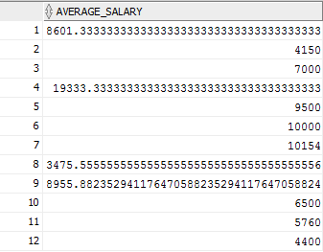

**Group by (Having)**

HAVING Clause is used with GROUP BY Clause to restrict the groups of returned rows where condition is TRUE.

Syntax:

|  |
| --- |
| SELECT expression1, expression2, ... expression_n,   aggregate_function (aggregate_expression)  FROM [table](https://www.javatpoint.com/oracle-having-clause)s  WHERE conditions  GROUP BY expression1, expression2, ... expression_n  HAVING having_condition; |

**HAVING Example: (with GROUP BY SUM function)**

|  |
| --- |
| SELECT department_id, SUM(salary) AS "Total Salary"  FROM employees  GROUP BY department_id  HAVING SUM(salary) < 100000; |

**HAVING Example: (with GROUP BY MIN function)**

|  |
| --- |
| SELECT Department_ID,  MIN(salary) AS "Lowest salary"  FROM employees  GROUP BY Department_ID  HAVING MIN(salary) < 15000; |

Sample Output:

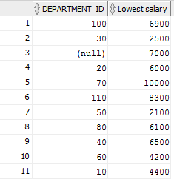

**HAVING Example: (with GROUP BY MAX function)**

|  |
| --- |
| SELECT Department_ID,  MAX(salary) AS "Highest salary"  FROM employees  GROUP BY Department_ID  HAVING MAX(salary) > 3000; |

Sample Output:

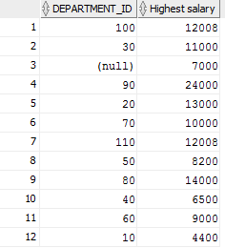

**Sub Queries:**

A Subquery is a query within another SQL query and embedded within the WHERE clause.

Important Rule:

* A subquery can be placed in a number of SQL clauses like WHERE clause, FROM clause, HAVING clause.
* You can use Subquery with SELECT, UPDATE, INSERT, DELETE statements along with the operators like =, <, >, >=, <=, IN, BETWEEN, etc.
* A subquery is a query within another query. The outer query is known as the main query, and the inner query is known as a subquery.
* Subqueries are on the right side of the comparison operator.
* A subquery is enclosed in parentheses.
* In the Subquery, ORDER BY command cannot be used. But GROUP BY command can be used to perform the same function as ORDER BY command.

**NOTE**:

Subqueries are useful when a query is based on unknown values.

**Sub Queries with SELECT Statement:**

Syntax:

|  |
| --- |
| SELECT column_name  FROM table_name  WHERE column_name expression operator  ( SELECT column_name  from table_name WHERE ... ); |

**Types of Subqueries**:

1. **Single Row Sub Query**: Sub query which returns single row output. They mark the usage of single row comparison operators, when used in WHERE conditions.
2. **Multiple row sub query**: Sub query returning multiple row output. They make use of multiple row comparison operators like IN, ANY, ALL. There can be sub queries returning multiple columns also.
3. **Correlated Sub Query**: Correlated subqueries depend on data provided by the outer query. This type of subquery also includes subqueries that use the EXISTS operator to test the existence of data rows satisfying specified criteria.

**Single Row Sub Queries:**

* Return only one row
* Use single-row comparison operators

|  |  |
| --- | --- |
| Operator | Meaning |
| = | Equal to |
| > | Greater than |
| >= | Greater than or equal to |
| < | Less than |
| <= | Less than or equal to |
| <> , =! | Not equal to |

|  |
| --- |
| SELECT First_Name, Job_ID FROM Employees WHERE job = ( SELECT job_ID FROM Employees WHERE empno=7369 ) |

Sample Output:

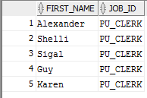

**Single Row Functions:**

Finds the employees who have the highest salary:

|  |
| --- |
| SELECT      employee_id, first_name, last_name, salary  FROM      employees  WHERE      salary = (SELECT              MAX(salary)          FROM              employees) |

Sample Output:



**Finds all employees who salaries are greater than the average salary of all employees:**

|  |
| --- |
| SELECT      employee_id, first_name, last_name, salary  FROM      employees  WHERE      salary > (SELECT              AVG(salary)          FROM              employees) |

Sample Output:

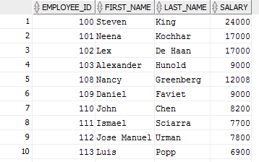

**Multiple row sub query:**

* Return more than one row
* Use multiple-row comparison operators
* [> ALL] More than the highest value returned by the subquery
* [< ALL] Less than the lowest value returned by the subquery
* [< ANY] Less than the highest value returned by the subquery
* [> ANY] More than the lowest value returned by the subquery
* [= A NY] Equal to any value returned by the subquery (same as IN)

**IN:**

|  |
| --- |
| SELECT first_name, department_id  FROM employees  WHERE department_id IN (SELECT Department_id  FROM departments  WHERE LOCATION_ID = 100) |

**Sample Output:**

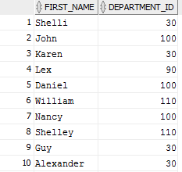

**ANY:**

|  |
| --- |
| SELECT employee_ID, First_Name, job_ID FROM EMPLOYEES WHERE SALARY < ANY  ( SELECT salary FROM EMPLOYEES WHERE JOB_ID = 'PU_CLERK' ); |

**Sample Output:**

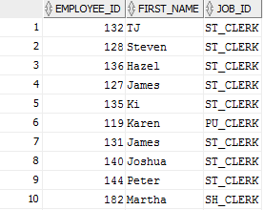

**ALL:**

|  |
| --- |
| SELECT employee_ID, First_Name, job_ID FROM EMPLOYEES WHERE SALARY >All  ( SELECT salary FROM HR.EMPLOYEES WHERE JOB_ID = 'PU_CLERK' ) AND job_ID <> 'PU_CLERK' ; |

Sample Output:

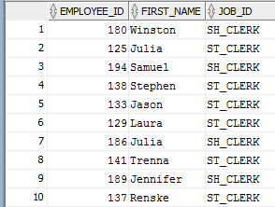

**Group By and HAVING IN SUB QUERIES:**

|  |
| --- |
| SELECT department_name, avg(salary)  FROM EMP_DETAILS_VIEW  GROUP BY department_name  HAVING avg(salary) > (  SELECT avg(salary)  FROM EMPLOYEES  ); |

**Sample Output:**

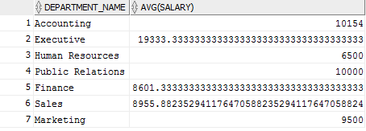

**SUBQUERIES AND DML:**

Subqueries with the INSERT Statement

* SQL subquery can also be used with the Insert statement. In the insert statement, data returned from the subquery is used to insert into another table.
* In the subquery, the selected data can be modified with any of the character, date functions.

**Syntax:**

|  |
| --- |
| INSERT INTO table_name (column1, column2, column3....)  SELECT *  FROM table_name  WHERE VALUE OPERATOR |

***You may login from a new user for DML sub Queries.***

Example: Let's assume we have an EMPLOYEE_BKP table available which is backup of EMPLOYEE table having all the attributes of Employees table

|  |
| --- |
| INSERT INTO EMPLOYEE_BKP  SELECT * FROM EMPLOYEES  WHERE job_ID IN (SELECT job_id  FROM jobs WHERE job_title='Accountant'); |

**Subqueries with the UPDATE Statement**

The subquery of SQL can be used in conjunction with the Update statement. When a subquery is used with the Update statement, then either single or multiple columns in a table can be updated.

**Syntax**

|  |
| --- |
| UPDATE table  SET column_name = new_value  WHERE VALUE OPERATOR     (SELECT COLUMN_NAME     FROM TABLE_NAME     WHERE condition); |

**Example:**

The given example updates the SALARY by 10 times in the EMPLOYEE table for all employee whose minimum salary is 3000.

|  |
| --- |
| Update employees  set salary= salary+(0.1*salary)  WHERE job_ID IN (SELECT job_ID  FROM jobs WHERE min_salary=3000); |

**Subqueries with the DELETE Statement**

The subquery of SQL can be used in conjunction with the Delete statement just like any other statements mentioned above.

**Syntax**

|  |
| --- |
| DELETE FROM TABLE_NAME  WHERE VALUE OPERATOR     (SELECT COLUMN_NAME     FROM TABLE_NAME     WHERE condition); |

**Example:**

Let's assume we have an EMPLOYEE_BKP table available which is backup of EMPLOYEE table. The given example deletes the records from the EMPLOYEE_BKP table for all EMPLOYEE whose end date is ’31-DEC-06’.

|  |
| --- |
| Delete from employee_BKP  WHERE job_ID IN (SELECT job_ID  FROM job_History WHERE end_Date='31-Dec-06'); |

|  |
| --- |
| SELECT  e.employee_id,  e.first_name,  e.last_name,  (SELECT job_title FROM jobs WHERE job_id = e.job_id) AS job_title,  (SELECT department_name FROM departments WHERE department_id = e.department_id) AS department_name,  (SELECT city FROM locations WHERE location_id = d.location_id) AS department_location,  (SELECT region_name FROM regions WHERE region_id = r.region_id) AS region_name  FROM  employees e,  departments d,  locations l,  regions r  WHERE  e.department_id = d.department_id  AND d.location_id = l.location_id; |